2.1 a)

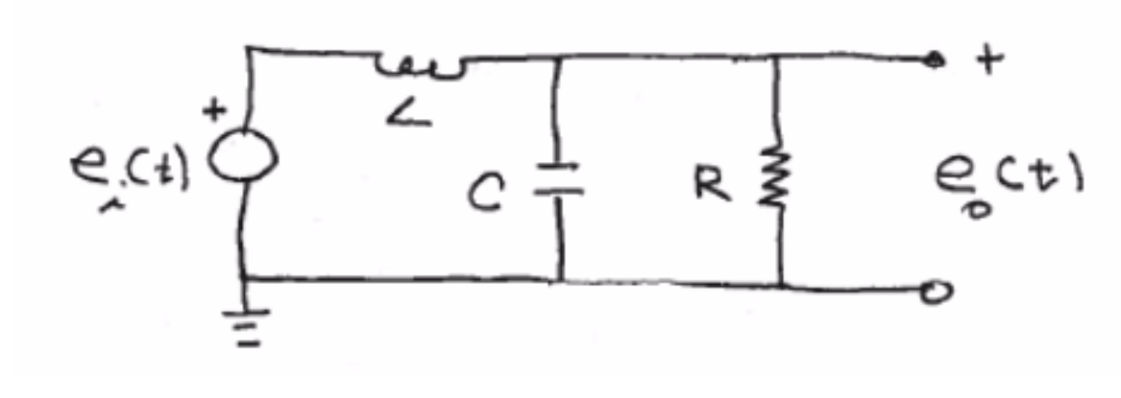Using KVL:

Loop 1:

Loop 2: Equivalent output: